How to get these values in R.

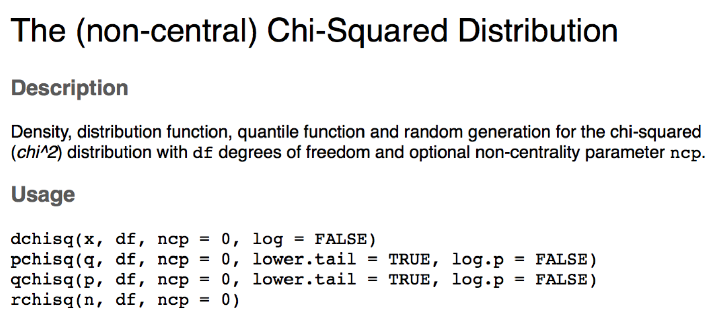

Which one should you use?

* P = probability distribution function
  + This function gives you the p-value associated with a specific X2(df) combination.
  + q = X2, df is either categories – 1 or (rows – 1)\*(columns – 1)
* Q = quantile distribution function
  + This function gives you the t cut off for an associated p and (df) combination.
  + p = alpha/p value, df is either categories – 1 or (rows – 1)\*(columns – 1)

Try:

